PRESTON DOTSEY

POURNA SENGUPTA

CSCI 3002 - 106

STARFare SECURITY COMMAND CENTRAL

**USER:** CHIEF OF SECURITY on active duty for STARFare mission 315-C on Ether-V76-244

**PROBLEM SPACE:** Easy, intuitive, self-learning computer equipped with voice activated command systems for ship-wide, public use. Verification of authorization, clearance, and confirmation of commands are all used to protect the ship's systems and ensure security .

**REQUIREMENTS GATHERING REPORT:**

**Methodology For Requirements Gathering:**

For our project, STARfare, much of our inspiration came from a favorite show of ours, Star Trek. Pulling inspiration from the voice-controlled computer system which sits aboard the various ships in the Star Trek universe, we decided to try to create our own voice-interface which could be used aboard modern day space craft. We aim to create a voice-interface which interacts with the various systems on a modern space craft which can execute commands that are spoken to it by the ship's crew and do so in a manner which is efficient and accurate. When in space, movement can become complicated, especially in time sensitive situations. The ultimate goal of STARFare is to allow crew members to access various systems and execute commands from anywhere aboard the ship by speaking voice commands, rather than having to physically move themselves to the various systems around the ship.

When preparing to design our interface, we used a combination of methods to research and narrow down what our projects requirements would be. First of all, we used our existing knowledge of the computer interfaces in Star Trek to serve as a platform to build off. We also consulted technical documents related to the computer technology in the show to further explore functions and capabilities to add into our interface project. As the show has a huge following, there is a massive amount of fan collected documents which dissect the tech used in the shows voice-interface technology and we were able to explore several possibilities through this.

Apart from the tech from the show, we also needed some real life examples in order to bring the tech from fantasy to reality. In order to do this we studied existing voice interface technology such as Alexa and Siri, which are two of the most widely used voice interfaces on the planet. We used these existing examples to research possible voice interactions which were both effective as well as easy for the user to grasp and felt they conveyed the intended command to the interface. We also conducted real world interviews with two subjects. The subjects were Preston’s fiancee and Pournas boyfriend. Finding people who worked in the fields of voice command technology was not possible, but both interview subjects use voice interfaces on a regular basis and were able to offer valuable feedback on effective communication needs and styles, as well as emotional implications of trusting the interface to function correctly.

**SUMMARY OF DATA GATHERING:**

To gather our data, we used a variety of methods including interviews with subjects, drawing on the extensive knowledge of the Star Trek community and lore, as well as researched existing voice interface technology such as Siri and Alexa.

Through interviews with our respective partners, we were able to narrow down specific areas of concern and areas which we felt we needed to focus on more than others. Both of our interviewees expressed concern over trusted voice command interfaces when it came to matters of piloting a vehicle that they would be inside of. This was their biggest concern, as no other form of transportation they used employs this method of navigation. They both also expressed frustration with current voice interfaces such as those in Siri and Alexa. Inaccuracy in the interfaces leads to annoyance such as returning incorrect searches and misinterpreting words, leading to further mistrust of voice interfaces used in the capacity that STARFare would be used in. In order to gain user trust, we both agreed that accuracy would have to be practically perfect in order for users to trust the system. If STARFare were inaccurate, users would avoid using it and revert back to the physical controls they are more comfortable with.

Through research of existing voice interfaces, we came across several common problems which would need to be addressed. First of all, in order for the system to be able to be used, we would need to train it to interpret and recognize a variety of different vocal styles. This was an interesting problem we encountered with Alexa, as it has an incredibly hard time understanding scottish accents. If STARFare is to be successful, it would need to be able to be accurately used by all crew members aboard, regardless of their accent. Studying existing voice interfaces also revealed peoples frustration with inaccurate interpretation of words as the main reason they choose not to use these systems. If the system does not accurately interpret voice commands across a variety of dialects, the users will simply opt out of using it.

Our final source of data was the Star Trek community itself. The tech of Star Trek is amazingly detailed and has a surprisingly high amount of technical documents associated with it in the real world. The computer interface aboard Star Trek's ships is highly advanced and maintains a perfect degree of accuracy. This accuracy and ease of use fosters trust within the crew, who uses it in an almost second-nature fashion. This level of trust and experience can only come with using a system which is extremely accurate, effective, adaptable, fast, and operates in a fashion that is superior to physical interfaces. In order for STARFare to be successful, it has to be all of these things as well.

**REQUIREMENTS:**

After conducting our interviews and researching related technologies, we settled on the major requirements for our project to be effective:

1. Ability to accurately interpret and carry out commands. This is the most vital requirement to the project. As this is intended to be used aboard a spaceship command deck, if the interface is not able to accurately interpret and carry out commands, it is effectively useless. Space flight is a high demand and high precision task, and any interface that is involved with this task must have an almost near perfect accuracy in its execution. In order to attain this accuracy, the commands required must be clear and concise, the systems which interprets commands must be able to decipher the commands accurately, even with high amounts of background noise, and the system must be able to relay information back and forth between the crew and it’s systems with high speed.
2. Users must be able to trust the interface in crisis situations. As voice command interfaces have never been used in a space flight capacity, there exists a level of mistrust in users when using a voice-interface in potentially life threatening situations. In order for the system to be effective, the user has to trust that the interface will accurately interpret their intentions and commands and execute them in the manner that they intend. Our interview subjects both expressed apprehension about voice interfaces controlling such a high-stakes operation and building this trust in the user is of extremely high importance. In order to build this trust, repeated user testing will be required throughout all stages of development and testing.
3. Ability to be used across a wide variety of users through standardized interface commands and executions. As space flight is not a solitary endeavour, another major requirement is that the system is able to be operated by all members of the crew and not just the crew member in charge. Current space flight relies on team interactions and STARFare will also require team compatibility in order to be successful. In order to maintain team functionality, we will need to ensure that STARFare is able to process commands from all team members by encoding compatibility with multiple voices and speaking mannerisms. This will be achieved through extensive testing and machine learning procedures using a variety of vocal dialects and inflections to ensure that there is no loss of functionality between vocal differences.

**Ideation & Brainstorming Report**

**Consolidation Discussion:**

* **Agreed that mistrust of voice interfaces is a major hurdle. Effort will have to be made through repeated testing and interviews to build that trust.**

**Summary of Final Ideas:**

**Raw Sketches Notes:**

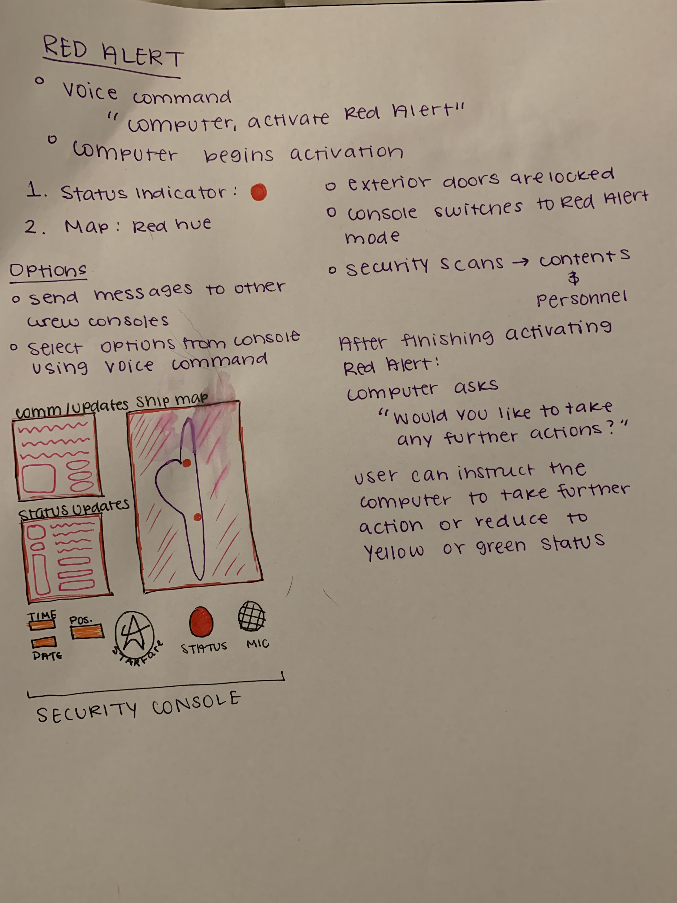

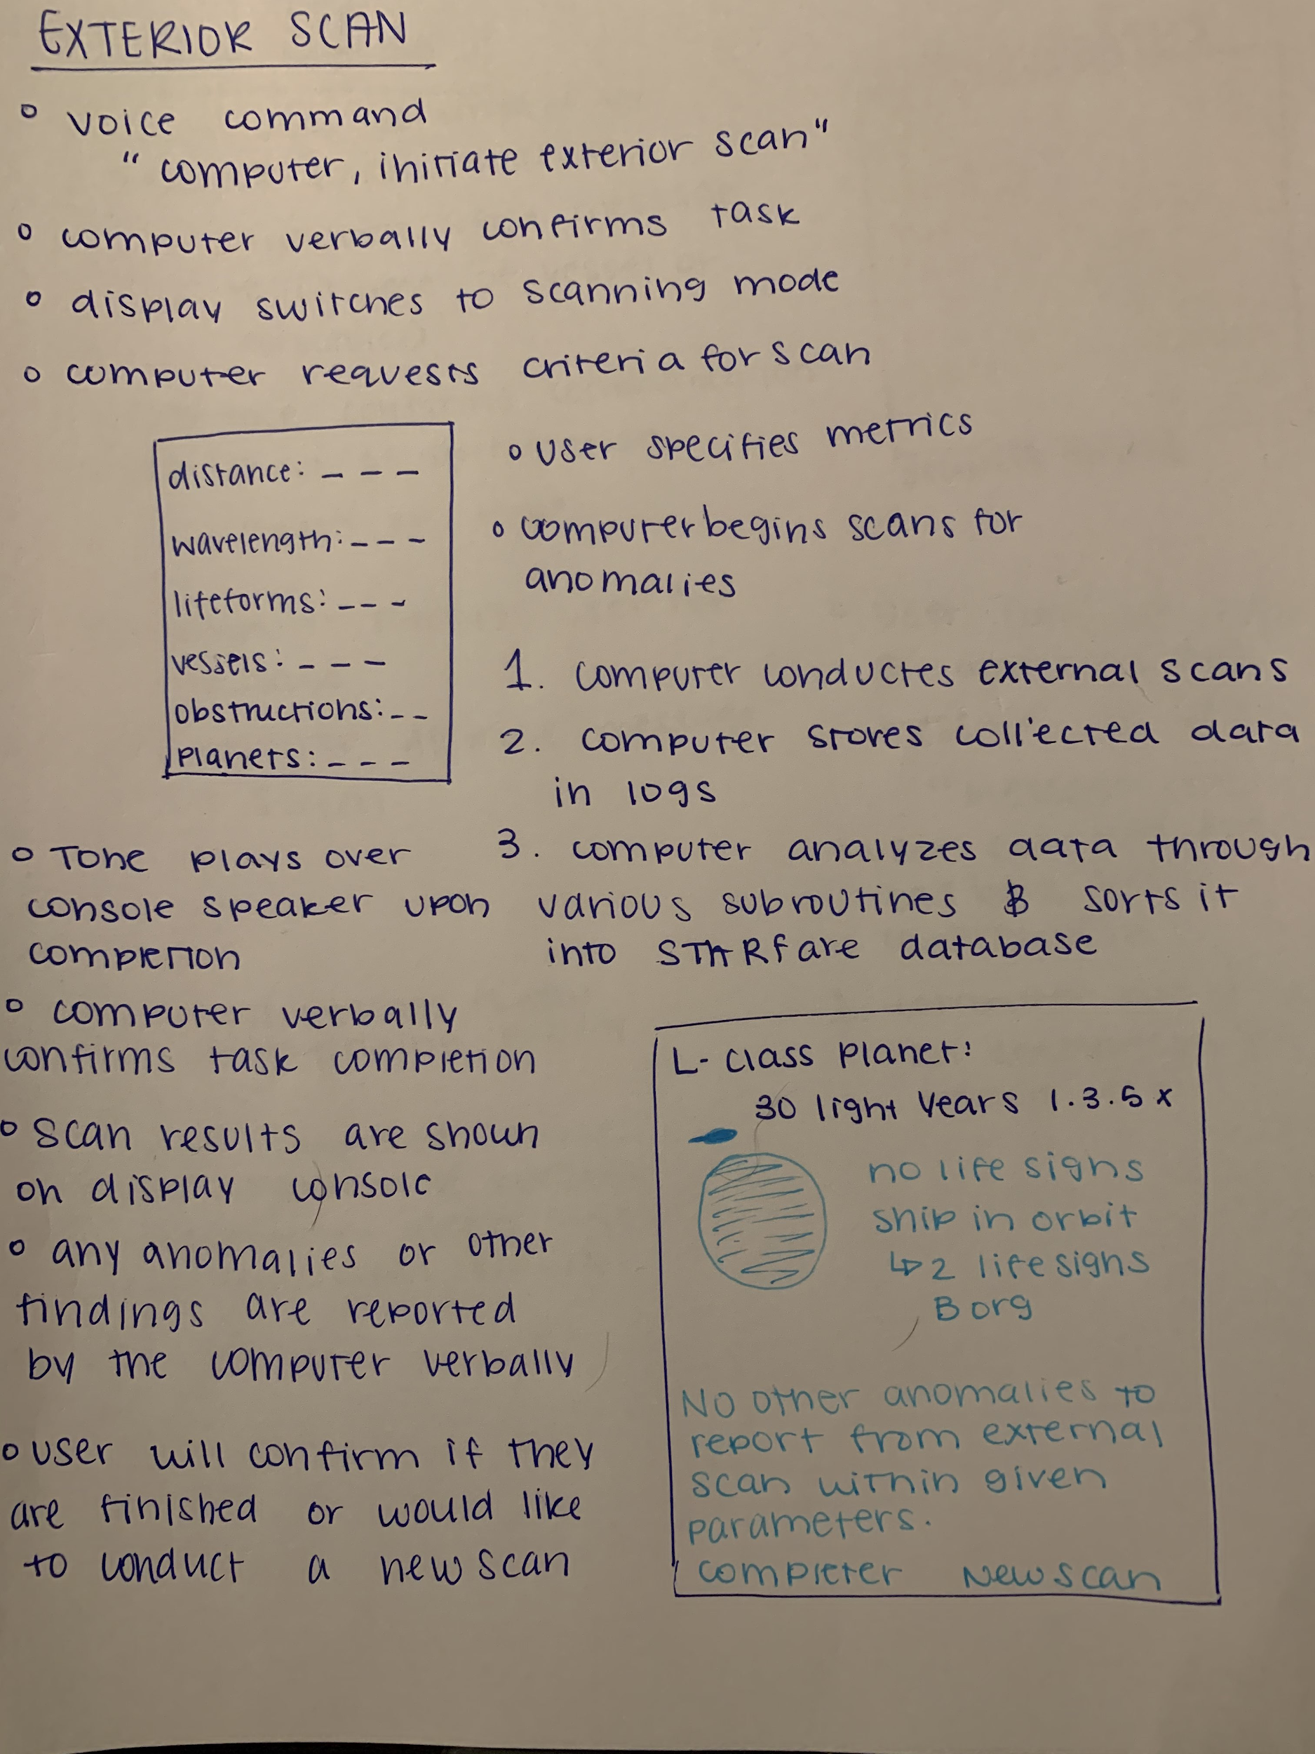

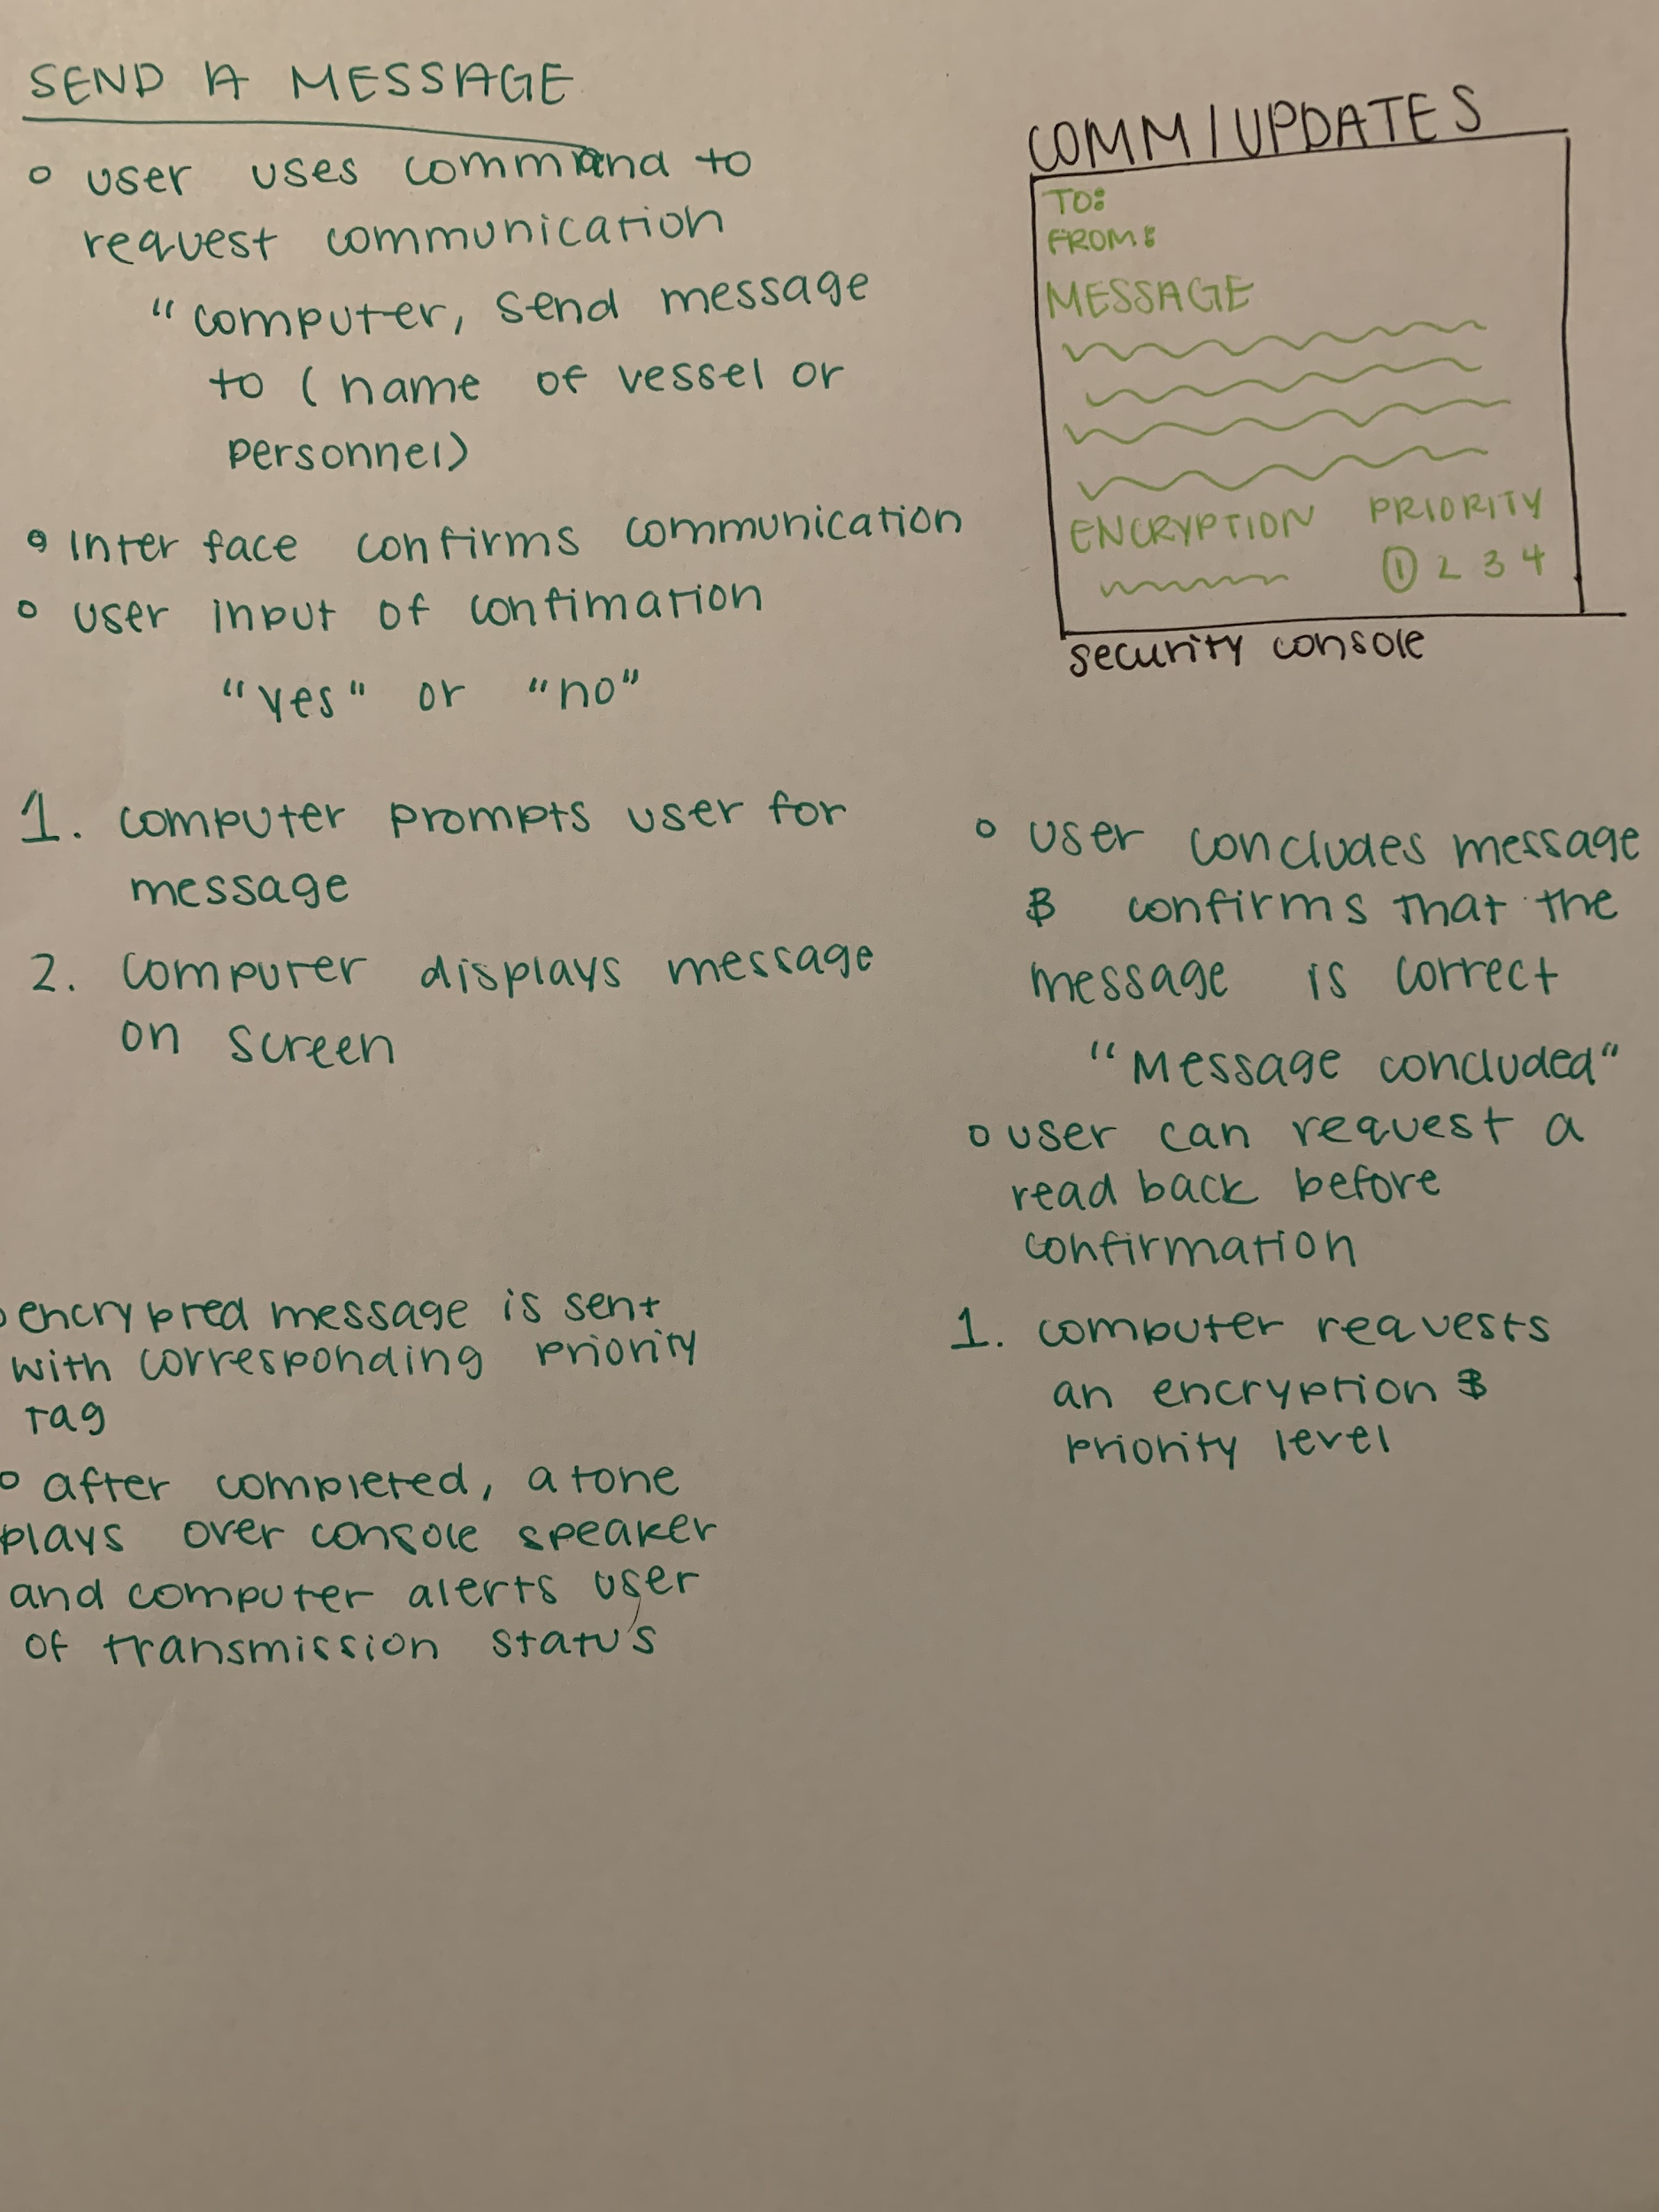

**Prototype and Three Tasks**

In order to show how our interface can carry out various tasks, we selected three tasks to prototype. We created the prototypes on Figma(see attached Figma file) to showcase three different tasks: 1. Initiating Red Alert Mode, 2. Sending a message to another space vessel, and 3. Performing an exterior scan. All three of these tasks are good examples of functions which showcase the interface's abilities to carry out tasks that are both routine and of high importance.

For the first task, entering Red Alert is a task which occurs during crisis situations, so we thought it would be good to show how our system will work in situations were the stakes are high and time is of the essence. First off, the ship would be in a green alert mode, one in which no warnings or security measures are in pace. At the first sign of a threat, the user, whether captain or security officer, would verbally command the interface to engage the Red Alert Mode with the command “Computer, engage Red Alert.” Once the computer hears this command, the computer console will switch from green to red and an alarm will begin to sound in the ship. The computer then initiates a series of automated procedures such as locking all exterior doors and initiating security scans of both the interior and exterior of the ship. The message screen will then show the ship's security status, as well as any incoming message from other crew members or external sources. This signals the ship's full entrance into Red Alert and the Computer will verbally ask the user what further actions they would like to take. The USer can then either instruct the computer to take further security actions, or stand down from Red Alert.

The second task is that of sending a message to another vessel in space. The first step is to verbally ask the computer, “ Computer, send a message to (name of intended vessel).” The interface will then confirm the message destination and the user will respond yes or no. The computer will then prompt the user to speak their message.

As the user recites their message, the computer will display the recorded message on the computer screen for the user to visually check as it is being recorded. After the message is recorded, the computer reads back the message to the user and confirms if the contents of the message are correct. The user will then confirm if the message contents are correct, verbally. The computer will then verbally ask the user to choose an encryption and priority level for the message. The user will then tell the computer what encryption level and priority they want to attach to the message and confirm it’s status. After the user gives confirmation, the message will be encrypted according to user preference by the computer and given a corresponding priority tag. The message is then compressed by the computer to increase broadcast range. Once the message is sent, a tone plays over the console speaker and the computer speaks a verbal confirmation of successful or unsuccessful message transmission.

The third task is that of performing an exterior scan. In order to initiate an exterior scan, the user will speak the command: “Computer, initiate exterior scan.”. The Computer will then verbally confirm it is initiating an exterior scan and the display screen will switch to its scanning mode. Computer asks for criteria from the user for the scan (distance, wavelength, etc.) and the user will specify what metrics they want the scan to include. The computer then begins to scan for anomalies (Biosigns, transmissions, etc.). During its active scanning, the computer will begin to store all collected data in various

logs and begin to analyze it with several various subroutines. Once the scan is completed, a tone will play and the computer verbally informs the user that the scan is complete. The results of the scan are displayed on the message screen, and anomalies are highlighted in bold. The computer will then verbally speak out anomalies of high

importance and ask the user if they would like to perform further scans. The user will then either confirm they want to perform more scans and the steps will repeat, or they can ask the computer to end further scans.

**READ ME:**

The process for this project has taken place entirely over zoom meetings, which we have had regularly. The brainstorming for ideas has been a collaborative process the whole way through. For this milestone, the Requirements Gathering report was written by Preston Dotsey, The Ideation and Brainstorming Report was led and written by Pourna Sengupta, The Prototypes were split between Preston and Pourna, and the ReadMe was written by Preston Dotsey. Both partners feel that the work was split evenly between the two of them.